11.1.13 Editors - Shader Editor - Header - Add Menu - Script
Add menu - Script 1
Script 1
Properties 1
Internal / External 1
OSL 1

Add menu - Script

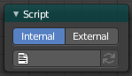
The Script menu contains actually just one menu item. A script node.

Script
In this node you can load OSL shaders.

Properties

Internal / External
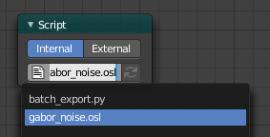
Use an internal OSL script from the script editor. Or use an external OSL script.
With internal you will see a drop down list with the opened scripts in the text editor.
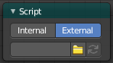
With external the dialog below turns into a string box with a file browser button with which you can load your script then.
This node has no inputs and no outputs. The input is the script. And OSL scripts outputs directly.

OSL
OSL was designed for node-based shading, and each OSL shader corresponds to one node in a node setup. To add an OSL shader, add a script node and link it to a text or an external file. Input and output sockets will be created from the shader parameters on clicking the update button in the Node or the Text editor.
OSL shaders can be linked to the node in a few different ways. With the Internal mode, a text data-block is used to store the OSL shader, and the OSO byte code is stored in the node itself. This is useful for distributing a blend-file with everything packed into it.
The External mode can be used to specify a .osl file from a drive, and this will then be automatically compiled into a .oso file in the same directory. It is also possible to specify a path to a .oso file, which will then be used directly, with compilation done manually by the user. The third option is to specify just the module name, which will be looked up in the shader search path.
The shader search path is located in the same place as the scripts or configuration path, under:
Linux
$HOME/.config/blender/2.79/shaders/
MS-Windows
C:\Users\$user\AppData\Roaming\Blender Foundation\Blender\2.79\shaders\
macOS
/Users/$USER/Library/Application Support/Blender/2.79/shaders/
Tip. For use in production, we suggest to use a node group to wrap shader script nodes, and link that into other blend-files. This makes it easier to make changes to the node afterwards as sockets are added or removed, without having to update the script nodes in all files.

